E-Waste Image Classification Using EfficientNetV2B0 (Transfer Learning)
Submitted by
Arghadeep Das

Bachelor of Technology (B. Tech)
in Computer Science & Engineering
(2022-26)
at Adamas University

Project Guide / Mentor Name:
Kunal Gupta

Period of Internship: 21ST January 2026 – 31st March 2026

Report submitted to: IDEAS – Institute of Data Engineering, Analytics and Science Foundation, ISI Kolkata
1. ABSTRACT

This internship project applied deep learning techniques to image classification, focusing on automated identification of e-waste using EfficientNetV2B0.

This project focuses on developing an automated system for classifying electronic waste (e-waste) using deep learning techniques.
The rapid increase in e-waste poses serious environmental and health challenges due to improper disposal. Improper disposal of electronic waste can lead to pollution and harmful effects on human health. Manual classification is inefficient and error-prone. To address this issue, a transfer-learning-based model using EfficientNetV2B0 was implemented to accurately classify e-waste items. The model classifies e-waste images into different categories accurately. It was trained on a structured dataset containing 10 types of electronic items. Data preprocessing techniques such as resizing, normalisation, and augmentation were applied to improve performance. The trained model achieved high accuracy and demonstrated strong generalisation capability on unseen data. Additionally, a user-friendly interface was developed using Gradio for real-time prediction. This system can significantly enhance recycling processes and contribute to sustainable waste management.

2. INTRODUCTION
Electronic waste (e-waste) is one of the fastest-growing waste streams globally, posing significant environmental and public health challenges due to the presence of hazardous materials and improper disposal practices. Traditional methods of manual classification are labour-intensive, time-consuming, and prone to human error, making them inefficient for large-scale waste management systems.
With the rapid advancement of artificial intelligence, deep learning techniques—particularly convolutional neural networks (CNNs)—have demonstrated exceptional performance in image classification tasks. These techniques provide an opportunity to automate the identification and categorisation of e-waste, thereby improving efficiency and accuracy.
In this project, an AI-based automated solution is developed for e-waste image classification using transfer learning. A pre-trained EfficientNetV2B0 model is fine-tuned to classify electronic waste images into ten distinct categories, such as PCB, mobile, battery, and others. Transfer learning enables the model to leverage pre-learned features from large datasets, significantly reducing training time while maintaining high performance.
The methodology involves dataset preparation, data preprocessing, model development, training, and evaluation using appropriate performance metrics such as accuracy, precision, and recall. Data augmentation techniques, including rotation, flipping, and zooming, are applied to improve model generalisation and reduce overfitting.
Furthermore, a user-friendly interface is developed using Gradio to enable real-time prediction and practical usability of the model. The primary objective of this project is to demonstrate how deep learning can be effectively utilised to automate e-waste classification, thereby supporting efficient recycling processes and promoting sustainable waste management practices.
Training Topics Covered (First 2 Weeks)
- Python for Data Science
- Image Processing Basics
- Machine Learning Fundamentals
- Deep Learning Concepts
- Transfer Learning
- Model Evaluation Techniques
- Data Preprocessing & Augmentation

3. Project Objective
- To develop and train a deep learning-based image classification model using EfficientNetV2B0 for accurate identification of e-waste items.

- To utilise transfer learning techniques to improve model performance while reducing training time and computational cost.

- To classify electronic waste into multiple categories, such as PCB, mobile, battery, and other devices, based on visual features.

- To evaluate and analyse model performance using key metrics such as accuracy, precision, recall, and confusion matrix.

- To design and deploy a user-friendly interface using Gradio for real-time e-waste prediction and practical application.

4. METHODOLOGY
The project focuses on image classification of e-waste using deep learning and transfer learning techniques. The model is developed using a curated dataset of electronic waste images categorised into multiple classes. Below are the detailed steps followed:
Step 1: Data Collection and Organisation
- Collected an E-Waste Image Dataset containing images of 10 categories, such as PCB, Mobile, Battery, Microwave, etc.
- Organised the dataset into three folders:
  - Training set
  - Validation set
  - Test set
- Ensured that all classes are equally distributed to avoid bias.
Step 2: Data Exploration and Visualisation
- Used Python libraries such as Matplotlib and Pandas to:
  - Analyse dataset structure and size
  - Visualise sample images from each class
  - Check class distribution across train, validation, and test sets
- Verified that the dataset is balanced and properly labelled.
Step 3: Data Preprocessing
- Resized all images to a uniform size (128 × 128 pixels) for model input.
- Normalised pixel values (scaled between 0 and 1) to improve training efficiency.
- Applied EfficientNet-specific preprocessing using preprocess_input.
Step 4: Data Augmentation
- Applied augmentation techniques to increase dataset variability and reduce overfitting:
  - Random rotation
  - Horizontal flip
  - Zoom
- This helped the model learn robust and generalised features.
Step 5: Model Design and Implementation
- Used EfficientNetV2B0 (pretrained on ImageNet) as the base model.
- Removed top layers and added:
  - Global Average Pooling layer
  - Dropout layer (0.2)
  - Dense layer with Softmax activation (10 classes)
- Frozen initial layers and fine-tuned deeper layers for better performance.

Step 6: Model Training and Validation
- Split the dataset into training, validation, and test sets.
- Compiled model using:
  - Optimiser: Adam
  - Loss Function: Sparse Categorical Cross-Entropy
  - Metrics: Accuracy
- Trained model for up to 15 epochs with Early Stopping to prevent overfitting.

Step 7: Model Evaluation and Visualisation
- Evaluated model performance using:
  - Accuracy
  - Precision, Recall, F1-score
  - Confusion Matrix
- Achieved high accuracy (~95%), indicating strong performance.
- Visualised results to analyse prediction behaviour and errors.

Step 8: Deployment
- Developed a Gradio-based web interface for real-time image classification.
- Users can upload e-waste images and receive instant predictions.

Tools and Libraries Used:
- Python 3, TensorFlow, Keras, NumPy, Pandas, Matplotlib, Seaborn, Scikit-learn, OpenCV, Pillow (PIL)
Tools Used
1. Python
It is used as the primary programming language for data preprocessing, exploratory data analysis, and the implementation of machine learning algorithms. Python's libraries, such as numpy, matplotlib, scikit-learn, and others, facilitated efficient data manipulation, visualisation, and model development.
2. TensorFlow & Keras
Used for constructing, training, and fine-tuning deep learning models. The EfficientNetV2B0 architecture was implemented using Keras within the TensorFlow framework.
3. Pillow (PIL) Used for loading image files and performing basic image processing operations (PIL / pillow).
4. Gradio: Used the gradio library to develop user-friendly web interfaces for deploying and interactively testing machine learning models.
5. Google Collab: Used for an interactive and collaborative coding environment. It provided a seamless platform for code execution, visualisation, and documentation.

Model Selection and Validation
- Choose EfficientNetV2B0 as the base model due to its high efficiency, accuracy, and optimised architecture for image classification tasks.
- Utilised transfer learning with ImageNet pre-trained weights to leverage previously learned features and reduce training time.
- Added custom layers (Global Average Pooling, Dropout, Dense with Softmax) to adapt the model for 10-class e-waste classification.
- Performed training and validation on separate datasets, ensuring that the test set was used only for final evaluation to maintain unbiased results.

FLOWCHART : Start
↓
Data Collection
↓
Data Exploration & Visualisation
↓
Data Preprocessing
(resizing, normalisation, labelling)
↓
Data Augmentation
(rotation, flip, zoom)
↓
Model Building
(EfficientNetV2B0 - Transfer Learning)
↓
Model Training & Validation
(train/val split, loss function, callbacks)
↓
Model Evaluation
(accuracy, precision, recall, confusion matrix)
↓
Result Visualisation & Analysis
(predictions, misclassifications)
↓
Deployment (Gradio Interface)
↓
Conclusion
↓
End
5. Data Analysis and Results.
This section summarises the findings from exploratory data analysis (EDA), model training, and evaluation of the e-waste image classification system.
Descriptive Analysis:
- The dataset consists of 10 classes of electronic waste, including PCB, Mobile, Battery, Microwave, Mouse, Printer, Television, Washing Machine, Keyboard, and Player.
- The dataset is divided into three subsets:
  - Training Set: 2400 images (240 per class)
  - Validation Set: 300 images (30 per class)
  - Test Set: 300 images (30 per class)
- The dataset is perfectly balanced, meaning each class has an equal number of images, which helps prevent bias during model training.
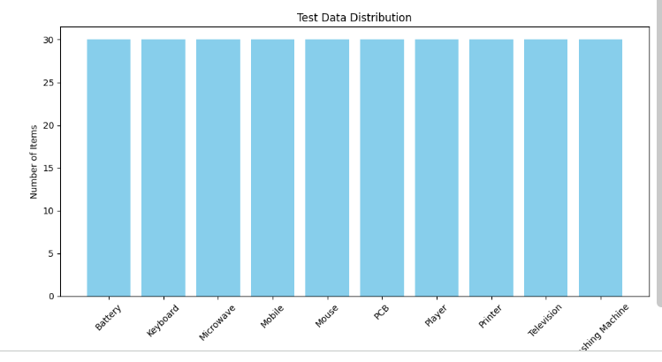
Test Data
Data Distribution Analysis:
- The training dataset shows uniform distribution across all 10 classes, as seen in the training data graph.
- Similarly, validation and test datasets also maintain equal distribution across all categories.
- This balanced structure ensures fair learning and unbiased evaluation of the model.
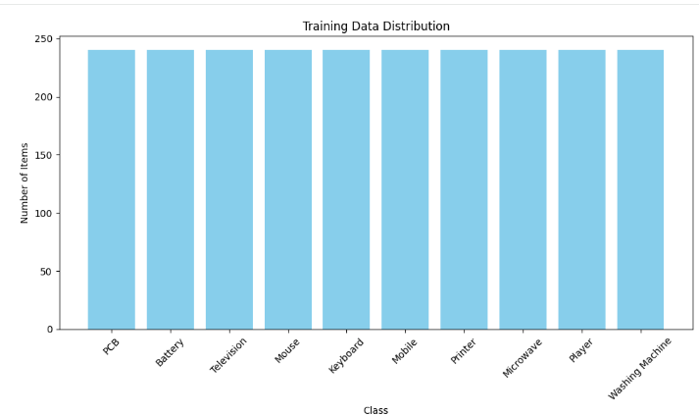
TRAININGDATA

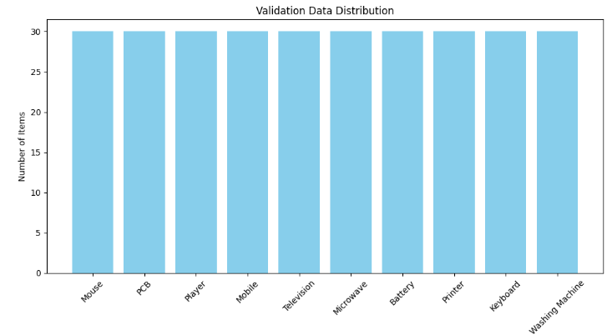
VALIDATION DATA

Working/OUTPUTS:
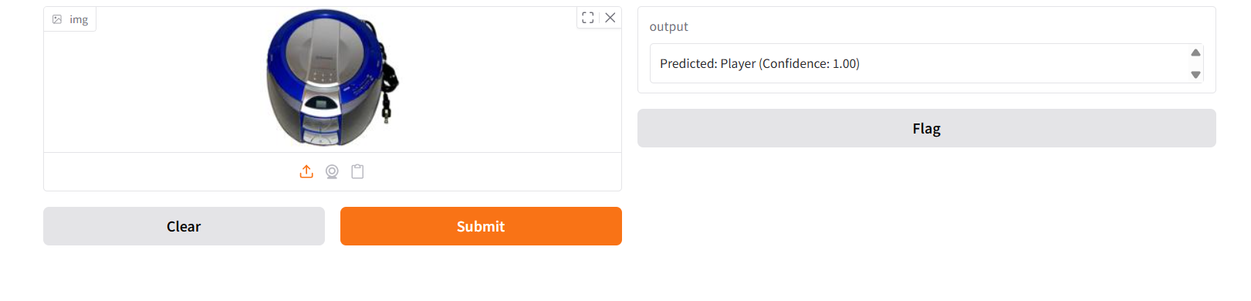
Fig1. Predicted: player True: Player
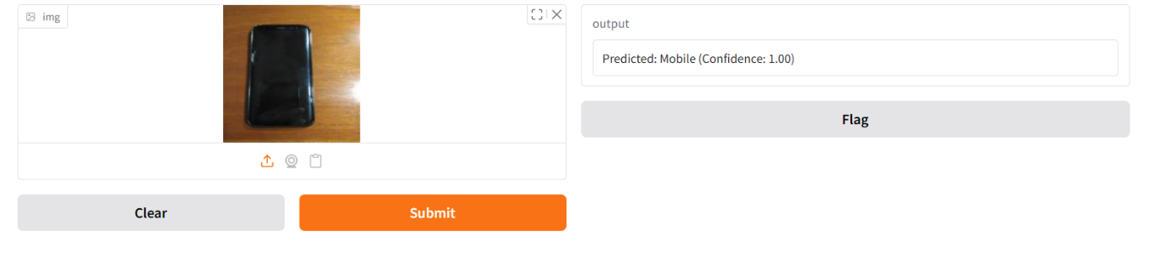
Fig2. Predicted: Mobile True: Mobile

Classification Model: EfficientNetV2B0
Final test accuracy: 95%. Precision, recall, and F1-score across all classes were consistently high, indicating strong model performance.
Metric | PCB | Player | Battery | Microwave | Mobile | Mouse
Precision | 0.97 | 0.94 | 0.88 | 1.00 | 0.91 | 0.97
Recall | 1.00 | 0.97 | 0.93 | 1.00 | 0.97 | 1.00
F1-score | 0.98 | 0.95 | 0.90 | 1.00 | 0.94 | 0.98
Metric | Printer | TV | WashingMachine | Keyboard
Precision | 0.93 | 0.97 | 1.00 | 1.00
Recall | 0.87 | 1.00 | 0.87 | 0.93
F1-score | 0.90 | 0.98 | 0.93 | 0.97

Classification Model: EfficientNetV2B0
Final test accuracy: 95%.
Precision, recall, and F1-score across all classes were consistently high
indicating strong model performance.
Overall Performance
- Accuracy: 95%
- Macro Average:
  - Precision: 0.95
  - Recall: 0.95
  - F1-score: 0.95
- Weighted Average:
  - Precision: 0.95
  - Recall: 0.95
  - F1-score: 0.95
Fig. 3 . Confusion matrix.
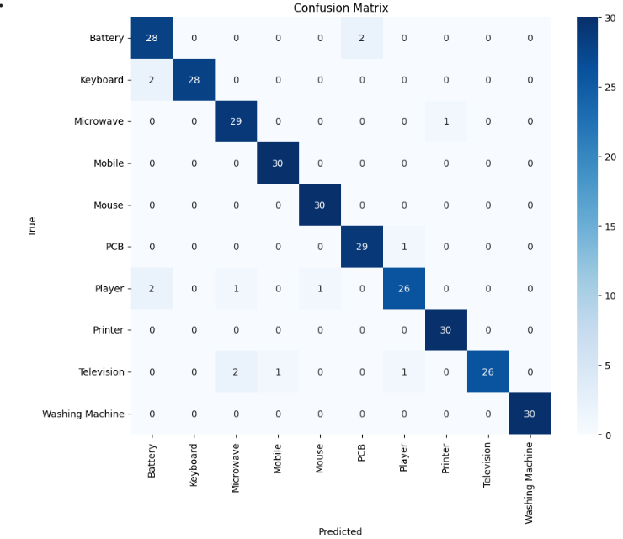

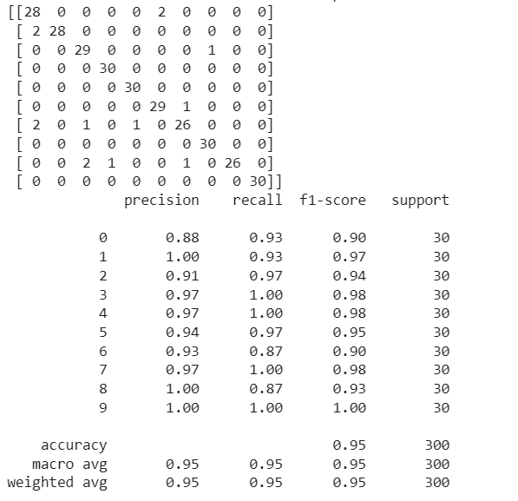
Fig4. Classification report and heatmap.
Fig5. Training Curve:
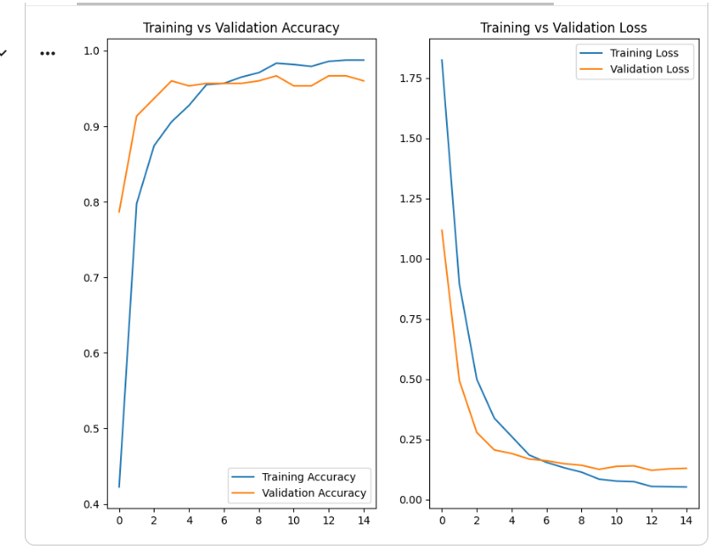

6. Conclusion:
This laboratory exercise successfully developed an accurate and reliable E-Waste Image Classification model utilising EfficientNetV2B0 and transfer learning techniques. The model demonstrated strong performance across both training and testing phases, achieving high accuracy and robust classification metrics for all 10 distinct e-waste categories, indicating its excellent ability to generalise to new, unseen image data.
The project highlights the efficacy of transfer learning for image classification, especially with limited datasets, and the efficiency of the EfficientNetV2B0 architecture. The developed model, coupled with its user-friendly Gradio interface, can serve as a valuable tool for automating e-waste sorting, thereby supporting efficient recycling processes and promoting sustainable waste management efforts. Further enhancements could involve advanced hyperparameter tuning or exploring alternative EfficientNetV2 variants for even greater robustness.

For Future Work, We Recommend:

- Training the model on larger and more diverse e-waste datasets to further improve generalisation and robustness.
- Experimenting with advanced deep learning architectures such as EfficientNetV2 variants, Vision Transformers (ViT), or DenseNet for enhanced performance.
- Integrating the system into a real-time automated waste sorting system using IoT or embedded devices.
- Exploring Explainable AI (XAI) techniques to better interpret and visualise model predictions.
- Developing a mobile or web-based application to make the system more accessible for real-world usage.

7. APPENDICES:
A: References:
TensorFlow and Keras official documentation:
https://www.tensorflow.org / https://keras.io

  - Scikit-learn documentation :

https://scikit-learn.org

  - Matplotlib and Seaborn documentation:

  - https://seaborn.pydata.org

  - B. Datasets:

Dataset Name: E-Waste Image Dataset

Source: https://www.kaggle.com/datasets/akshat103/e-waste-image-dataset
C. Other Document:
Source:
https://github.com/Argha-hub-art/IDEAS-ISI-Spring-Internship-2026

